FORMER LOCHSIDE LEISURE CENTRE
INSPECTION
November 2020

FORMER LOCHSIDE LEISURE CENTRE INSPECTION

Executive Summary

The former Lochside Leisure Centre was closed in February 2017 and a limited visual inspection has been undertaken to record any apparent deterioration since that time.

The inspection has not revisited the previously documented subsidence.

The building has some water ingress and the wooden floors have expanded due to the uncontrolled humidity in the building.

There is cracking evident in a number of locations throughout the building including in areas that have previously been repaired. Some crack locations have not previously been recorded or monitored. In places the cracking, like the subsidence, is beyond what is considered acceptable. The cause of the cracking is not identified. Any party interested in the property are advised to arrange their own surveys and professional advice.

Introduction

The former Lochside Leisure Centre was inspected on 17 November 2020. The purpose of this inspection was to give an overview of the property and note any significant deterioration since its use as a leisure centre. The report only covers rooms/areas where defects were noted at the time of the inspection.

All room references are as per the plans provided on the consultation page for Lochside Leisure Centre https://www.angus.gov.uk/lochsideconsultation. Photographs are provided in Appendix 1.

The building has previously suffered significant movement in the floor levels. This movement has been previously recorded and is not examined in detail in this report. Other reports on the consultation page for Lochside Leisure Centre gives details of previous reports on the floor and foundations movements, notably the contour plans of the floors which graphically show this movement.

The inspection was limited to a visual inspection, with only minor intrusion examination with limited non-destructive flooring material removed; no inspection of the ceiling void was undertaken; no inspection of the roof; and no checks of the utilities were undertaken. All inspections were taken at floor level/ground level.

The report details the defects noted at the time of inspection and makes no comment on the causation. Any party interested in the property are advised to arrange their own surveys and professional advice. This inspection report should not be relied upon in any way as to the condition of the building or the repairs/maintenance required.

EXTERNAL

Cracks to the south elevation
A walk round the outside of the building noted 45-degree cracks extending from each of the two 1st floor windows on south façade (Photo 1).

The cracking to the window to the south west, extends from the first floor all the way down to the ground floor fire escape (to green room 2). There has been a previous but smaller repair evidenced by the different colour of render (Photo 2).

The crack to the window to the south east extends from the first floor down towards the ground floor fire escape (to green room 1), but the full extend could not be determined from ground level. There has been a previous but smaller repair evidenced by the different colour of render (Photo 3).

Expansion Joints
There are regular movement joints around the building between the wall panels which are filled with mastic. A number of the joints are exhibiting tearing of the mastic infill to the expansion gap, indicating tension rather than compression of the material (Photo 4 & 6).

A number of the joints indicate a widening from the base to the higher level of the joint, This was illustrated on the east elevation panels to the drama studio, which show the expansion joint is circa 19 millimetres at ground level; and circa 27 millimetres at a height of 2 metres above ground level (Photos 5 & 6). This is replicated on the other joint to the same panel.

There is 45-degree minor cracking at ground level adjacent to one of the movement joint on the east elevation panels to the drama studio.

INTERNAL

General
The centre has been closed and boarded up for over three and a half years. At some point vandals had entered the building and have broken a number of the windows. There are also several ceiling tiles that have been removed, some of which were for access for decommissioning and the demolition contract and some potentially due to vandalism.

There is the smell of and evidence of damp on entering the building, with water ingress through the front door (Photo 7).

Ground Floor
Café
The area past the foyer, noted as café on the plan is well known to have sloped towards the main sports hall. This is illustrated by the distortion of the external glazed unit (boarded up) on the west side of this room (Photos 8 &9).

The doors leading towards the main sports hall exhibit the subsidence (Photo 10), that is perpendicular to the fall to the main sports hall, and the low point of the room is in front of the glazed viewing window to the sports hall. This is emphasised by some water ingress in this area with ponding at the viewing window.

The subsidence of the doors has been measured as 25 millimetres across the 1.8 metre frame. The doors have had to be adjusted over time to accommodate the subsidence with the west door having been planned down on the bottom edge. The west door is now sticking as it catches the floor which may be due to humidity.

Store 5
Store 5 exhibits numerous defects in 3 of the 4 walls to this room (Photo 11). The room was previously monitored with ‘tell-tales’ still in place on some of the cracks. The north wall has horizontal and vertical cracking in pillar, and cracking in the wall.

The east wall (to the drama studio) has stepped cracking at floor level and at ceiling level including through the brickwork at its north end (Photos 12 & 13). At the south end there is a vertical cracking at the doorway (Photos 14). The south wall has stepped crack at the door lintel extending to the ceiling (Photo 15).

Drama Studio
There are vertical and horizontal cracking at high level in south wall of the Drama Store.

Sports Hall Store
There are two sets of stepped cracks to the south east corner (shared wall with main hall) (Photos 16 & 17).The floor of the hall exhibits extensive cracking and is unlevel (Photo 18). The store has previously been repaired.

Sports Hall
The floor in the sports hall has expanded due to humidity and has buckled upwards in a number of places. At the time of inspection (and a previous visit 13 October 2020) there was no indication of water ingress.

There is repeat stepped cracking in the south wall at the site of a previous repair (Photo 19).

Squash Court Access Hall
Water ingress was noted.

Squash Court 1
The timber floor has expanded due to humidity and has buckled upwards in a number of places. At the time of inspection (and a previous visit 13 October 2020) there was no indication of water ingress.

There is a crack with evidence of previous repair in the west wall. The crack is vertical to a height of approximately 2.5 metres, and thereafter extends at 45 degrees towards the north wall for approximately 2 metres.

Hall 2
The double doors in this corridor show the nature of the subsidence with a level difference of 37 millimetres across the 1.8 metre frame. Like the café doors, these doors have also been adjusted over time to accommodate the subsidence with the south door having been planned down on the bottom edge (Photo 20).

Changing Room 3
Units in the north of the room have been removed. There is a crack in the north wall that is at somewhat less than 45-degree from ground level into the corner of the room and then vertical (Photo 21).

First Floor
Store 8
The floor slab has re-cracked along the line of a previous repairs (Photo 22).

Unnamed room between Store 8 and St 9
This room exhibits significant cracking, vertical in the north east corner and 45 degrees across the outside wall (Photo 23). The 45-degree cracking extends from above the false ceiling height to under the worktop counter potentially towards the floor cracking in Store 8 (see above). This cracking is aligned with the 45 degree external cracking on the south elevation of the building (see above). A small section of plaster was removed revealing a deeper fissure in the wall.

St 7 (opposite weights room)
There is a stepped crack at high level in the south wall/joined wall with the drama studio (Photo 24). This room is located directly above Store 5 (see above).

Weights
The floor exhibits cracking running north south and east west (Photo 25). This room is located directly above Store 5 (see above).

Store 7
Stepped cracking was noted to the west wall at the door lintel (Photos 26 &27).

Squash Court Viewing Gallery
Water ingress was noted.

Door access to climbing wall
Water ingress was noted.

Ian Cochrane
Director of Infrastructure
Angus Council
APPENDIX 1 PHOTOGRAPHS

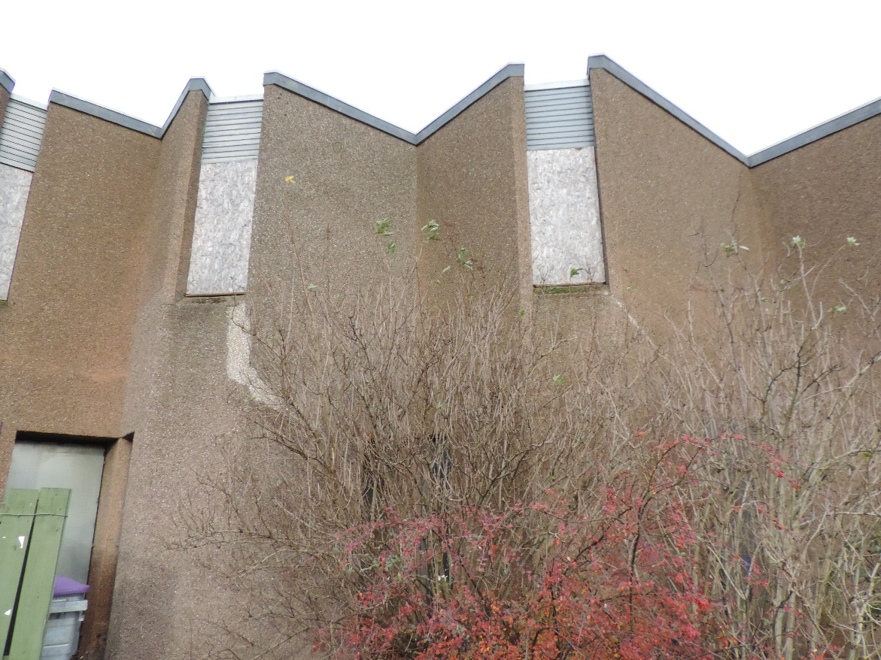

Photo 1 – South elevation with previous repairs

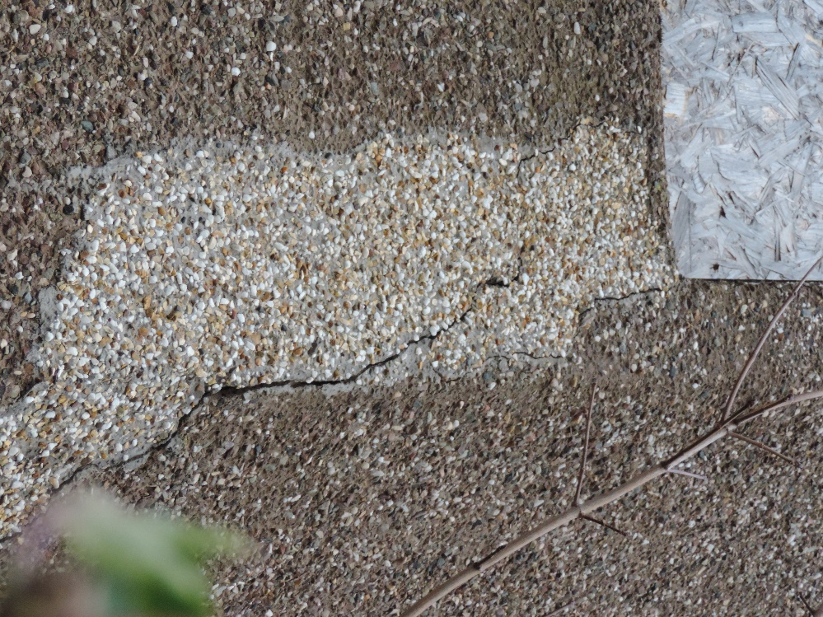
Photo 2 Cracking extending through previous repair
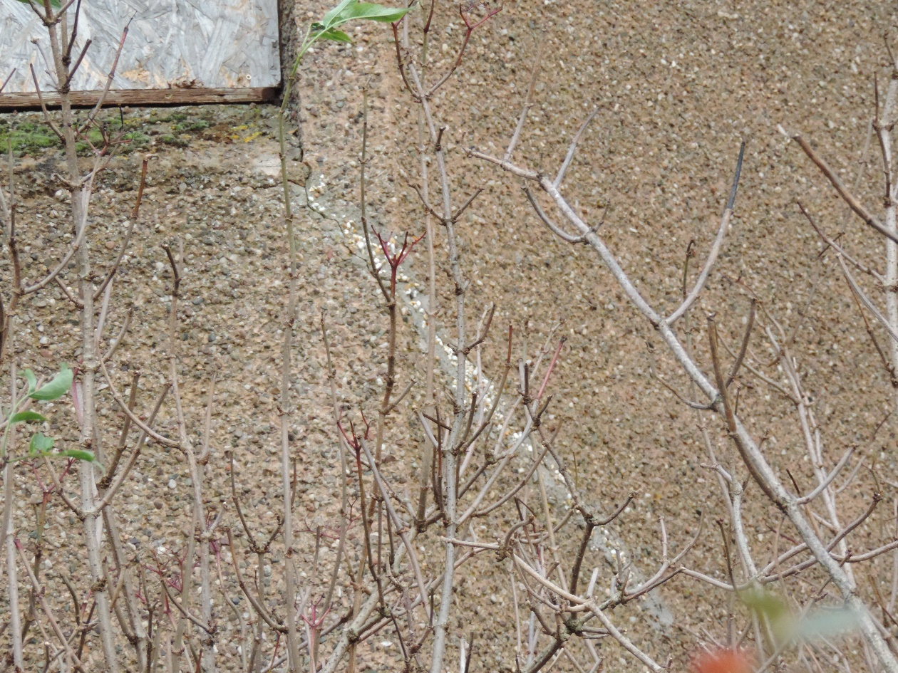
Photo 3 Cracking extending through previous repair

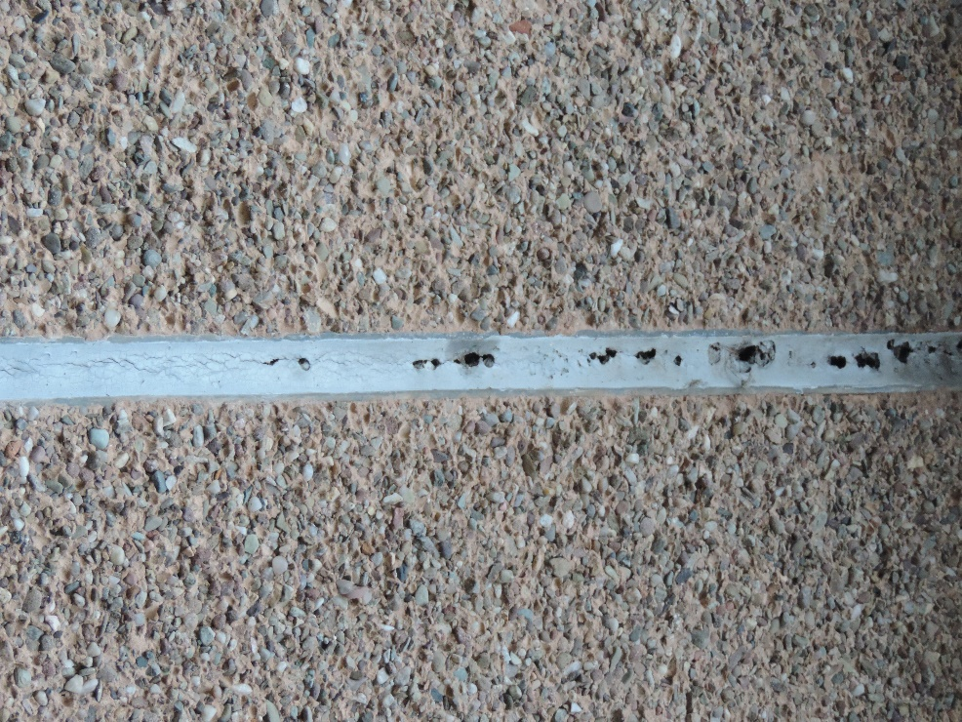
Photo 4 Tearing of movement joint mastic
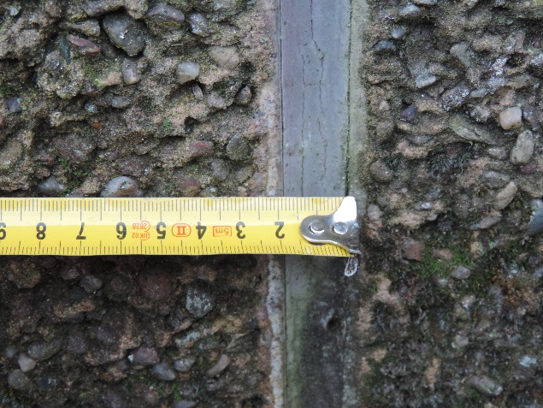
Photo 5 Measurement of movement joint to east elevation at ground level
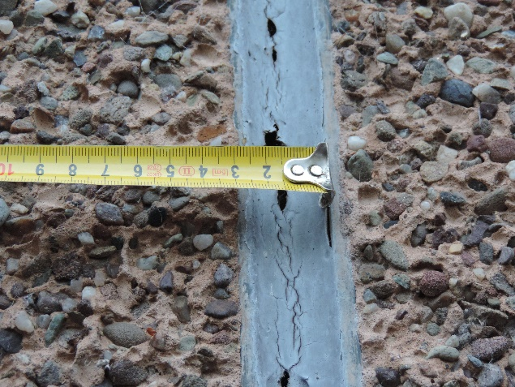
Photo 6 Measurement of movement joint to east elevation at 2 metre height

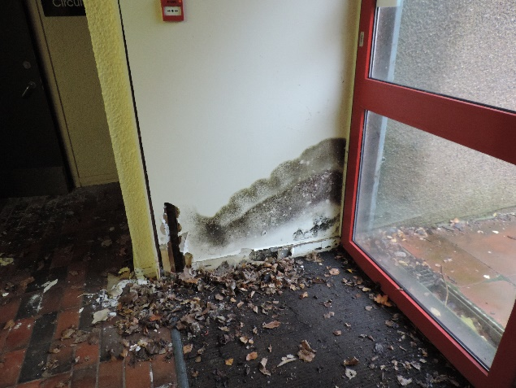
Photo 7 Water ingress at front door
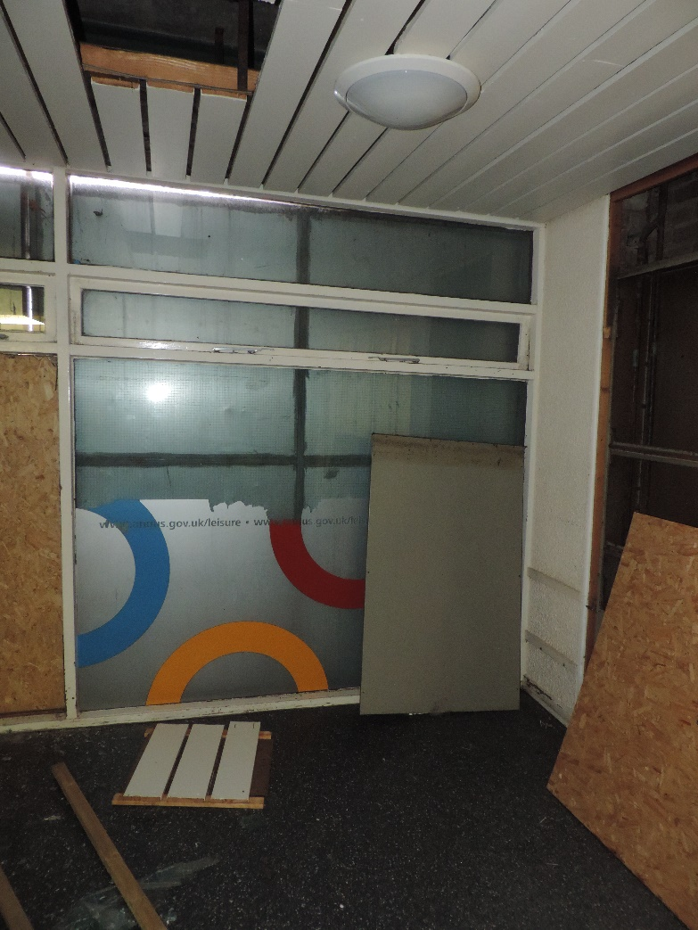
Photo 8 – Distorted glazed unit side of west of café area

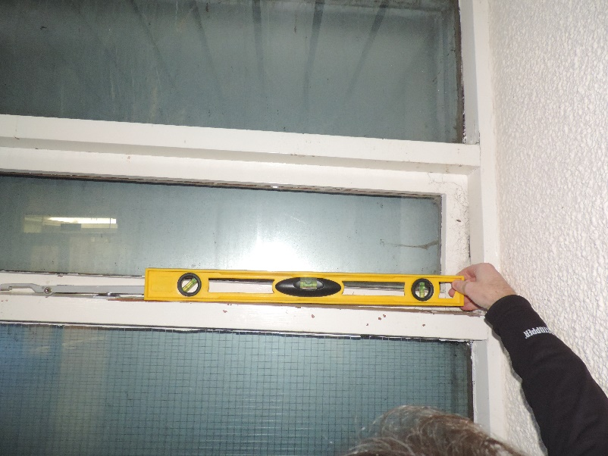
Photo 9 – extent of movement on glazed unit west side of café area (600mm spirit level)

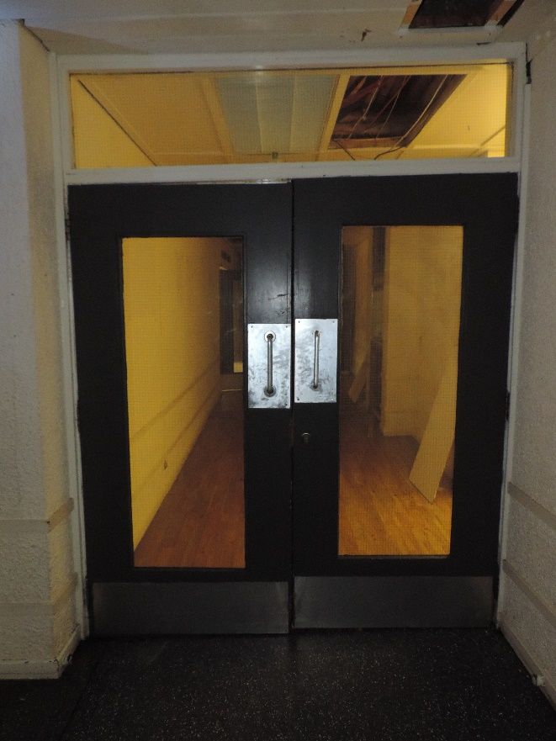
Photo 10 Distorted doors to main sports hall

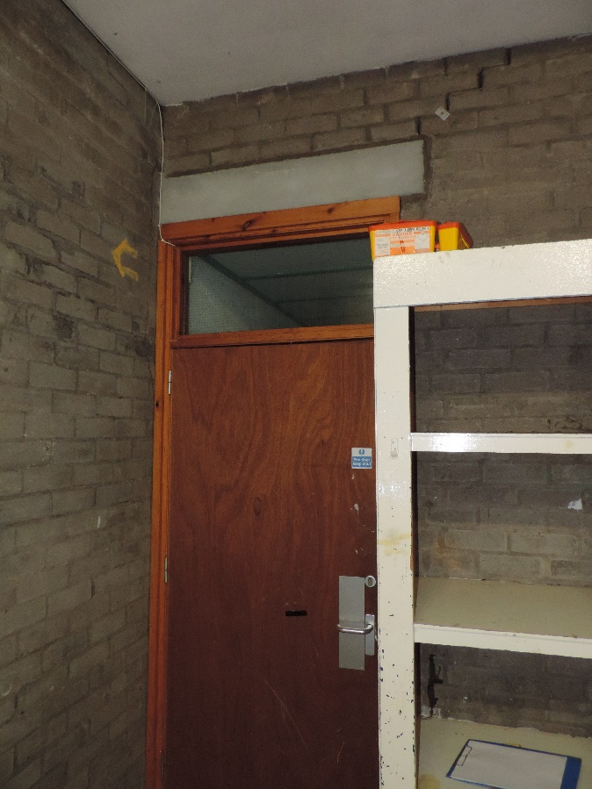
Photo 11 Store 5 overview

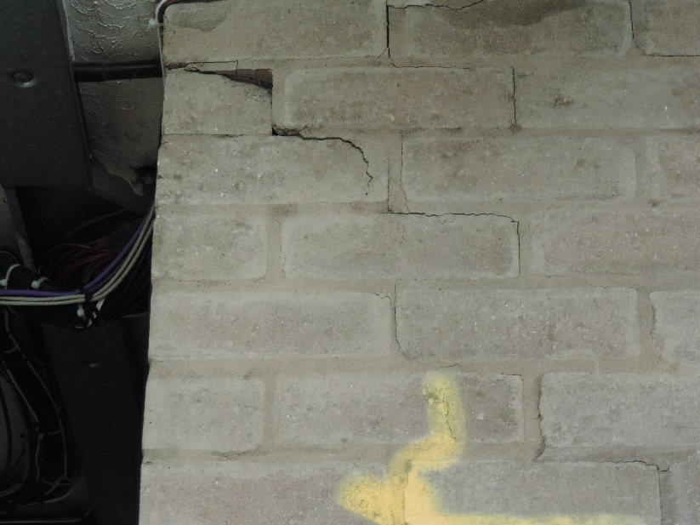
Photo 12 Store 5 East wall north end roof level

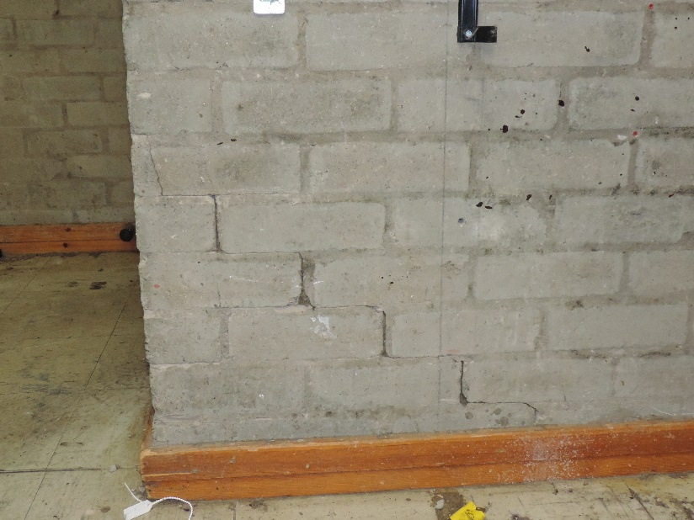
Photo 13 Store 5 East wall north end floor level

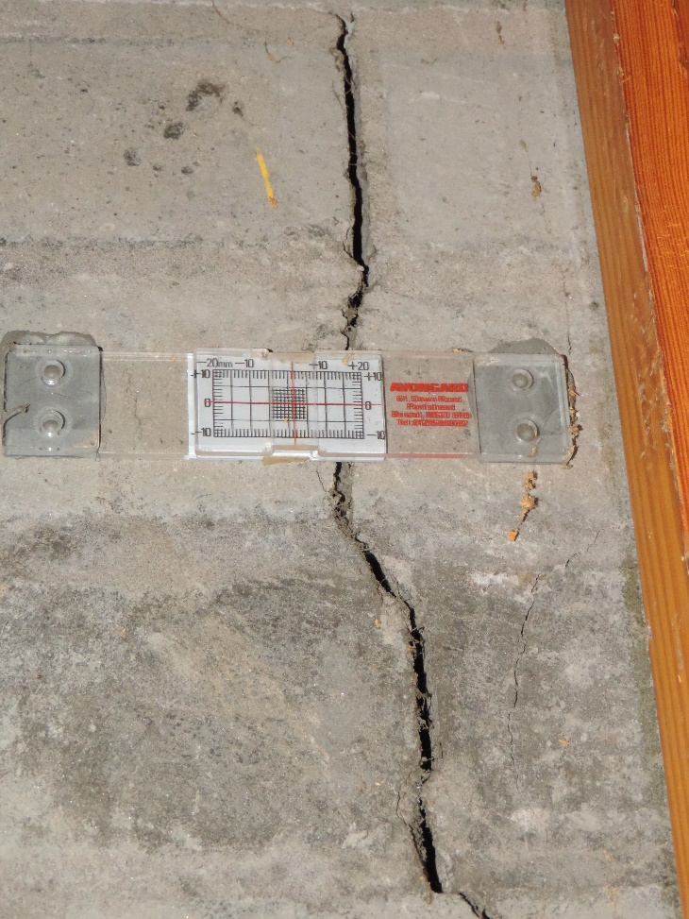
Photo 14 Cracks to brickwork Store 5 at door
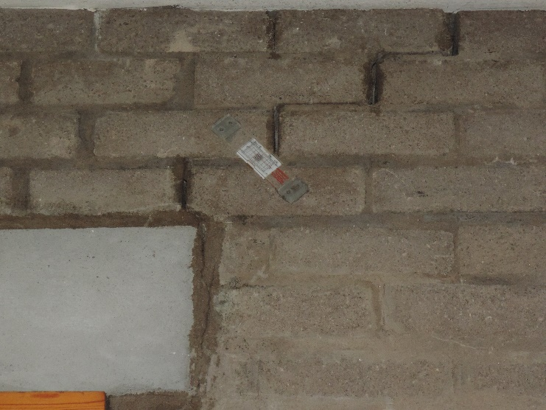 Photo 15 Stepped cracking above door lintel Store 5
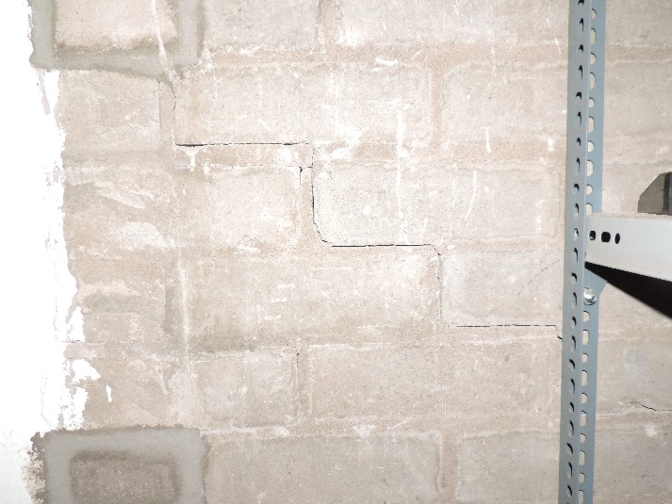
Photo 16 Sports Hall Store higher level stepped cracking above photo 17
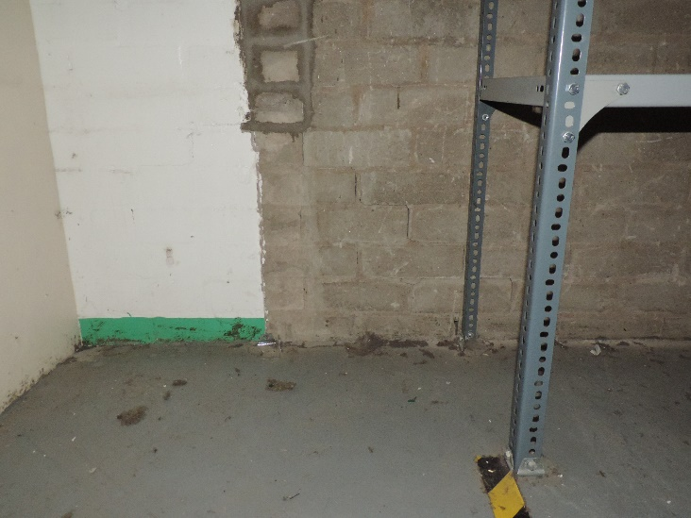
Photo 17 Sports Hall Store higher level stepped cracking below photo 16
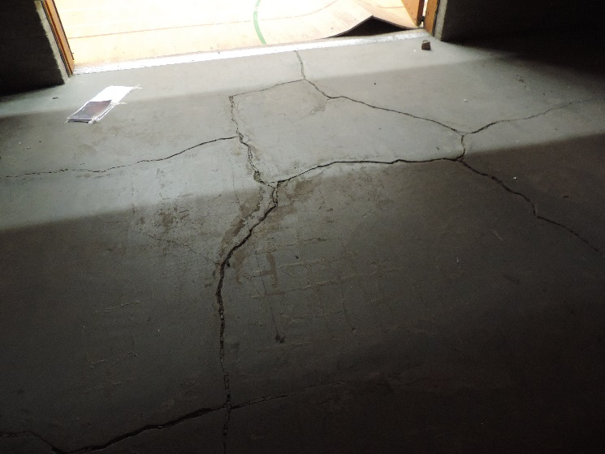
Photo 18 Cracking to Sports Hall Store floor
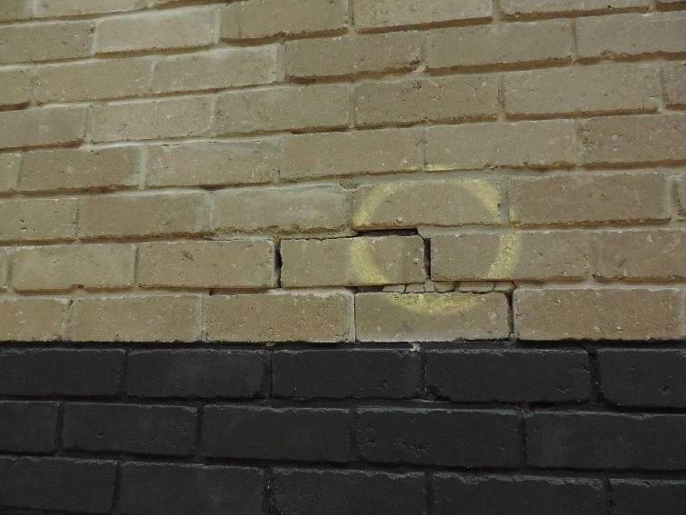
Photo 19 Cracking in previous repairs in Sports Hall south wall
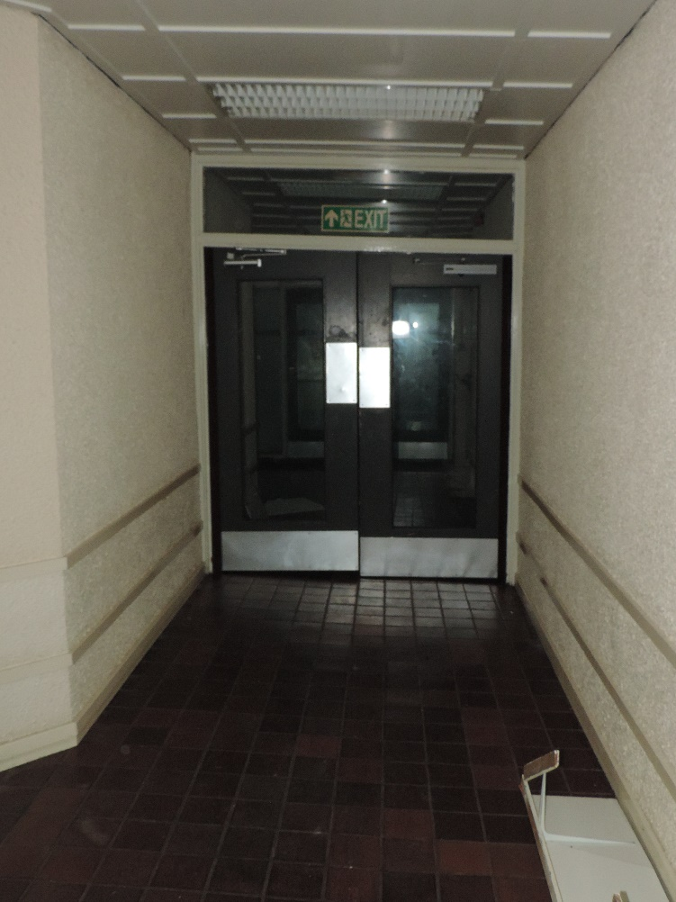Photo 20 Hall 2 – Distorted door frame and floor subsidence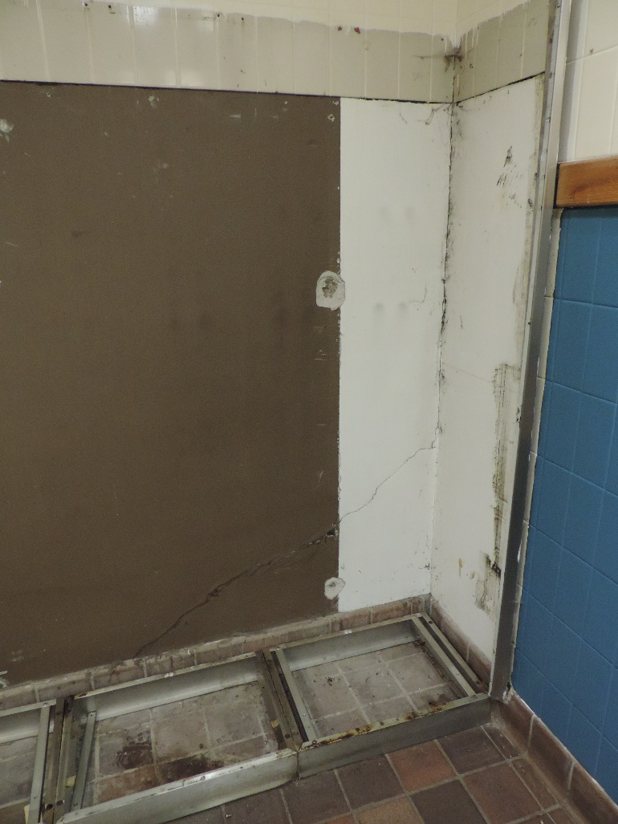 Photo 21 – Changing Room 3 Vertical and angled cracking

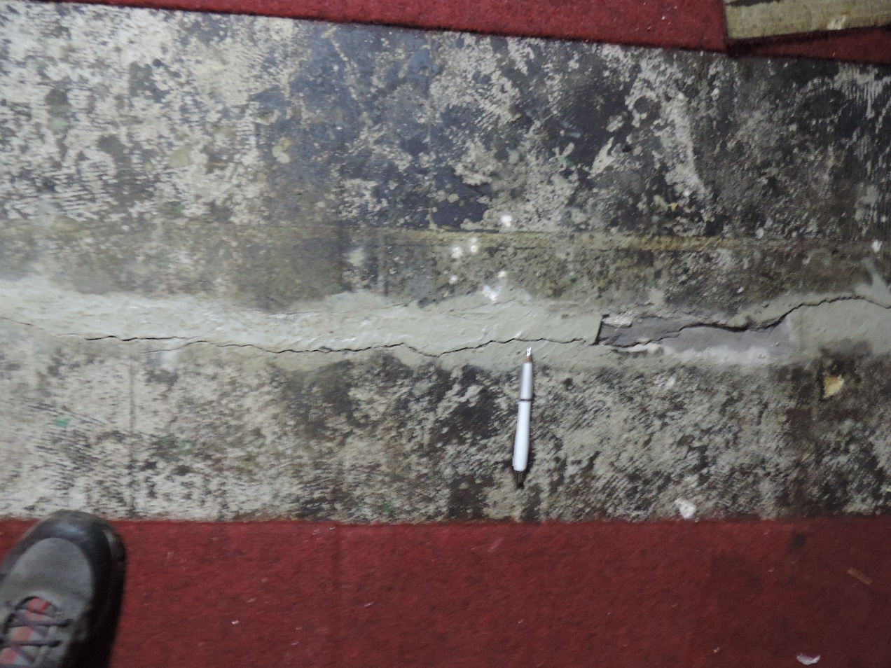
Photo 22 – Store 8 floor cracking along line of previous repair

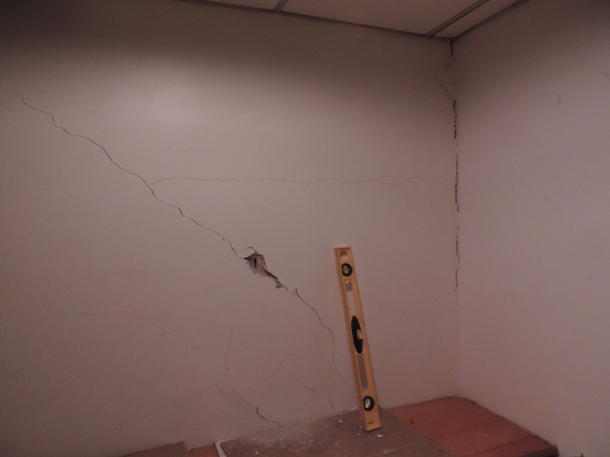
Photo 23 – Room between Store 8 & St 9 45 degree, and vertical cracking.

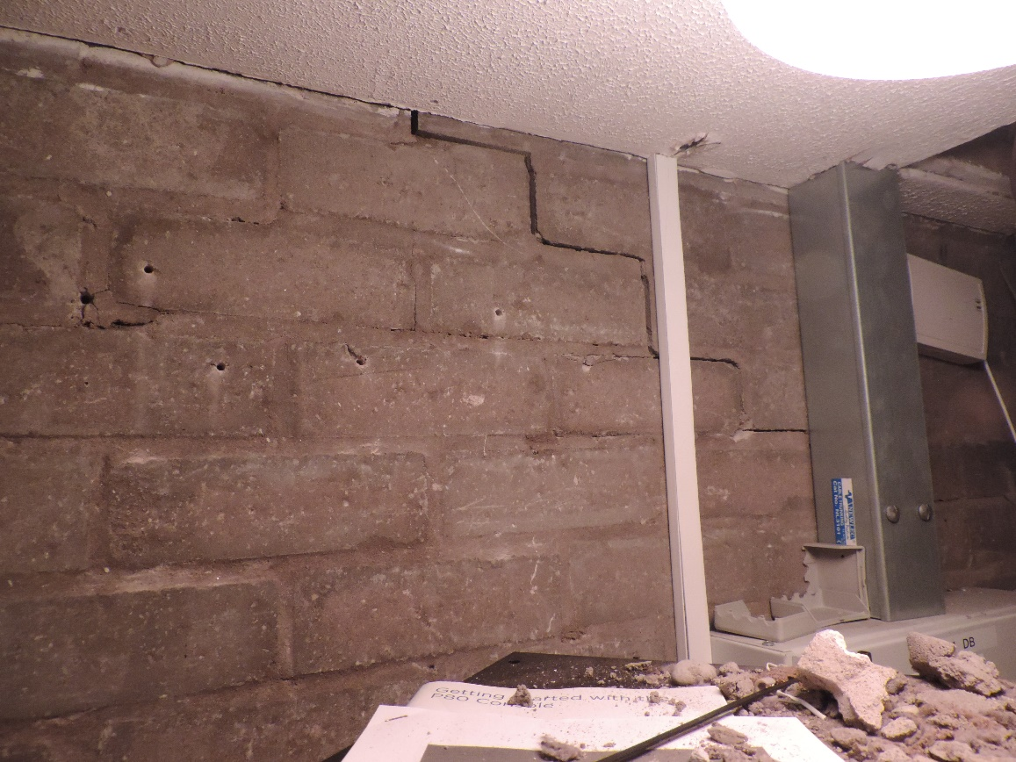
Photo 24 – St 7 stepped cracking at ceiling level

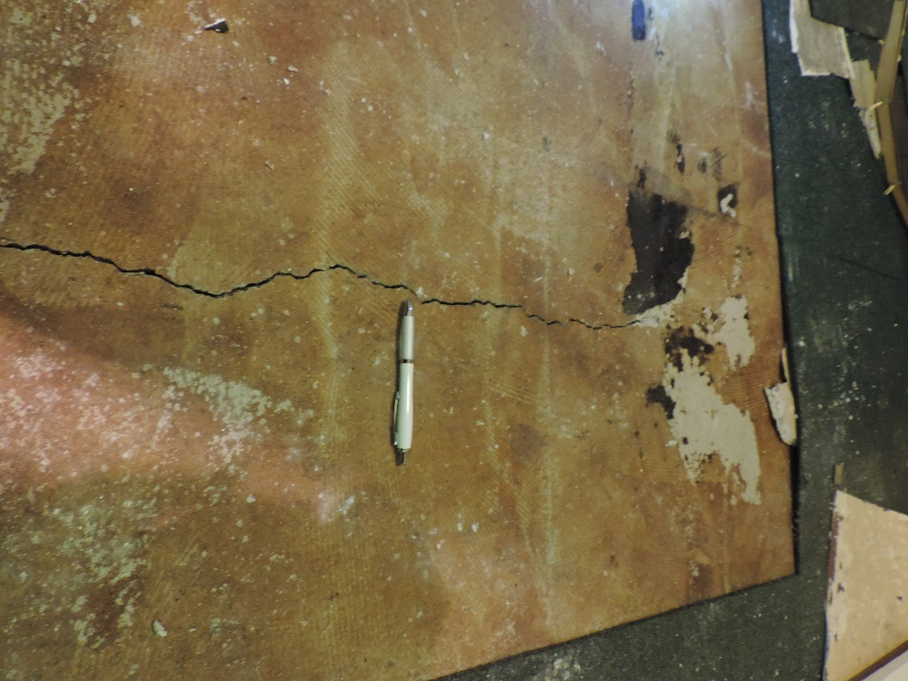
Photo 25 – Weights room floor slab cracking

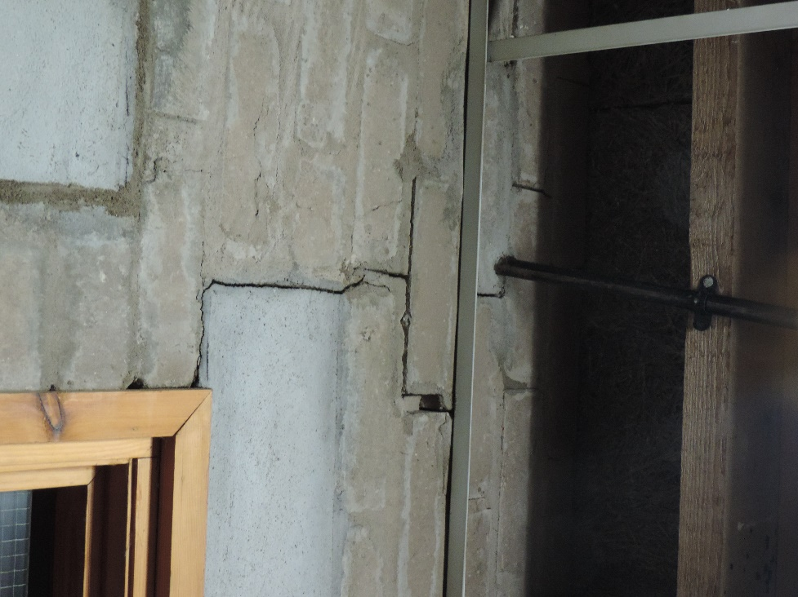
Photo 26 – Store 7 stepped cracking at door
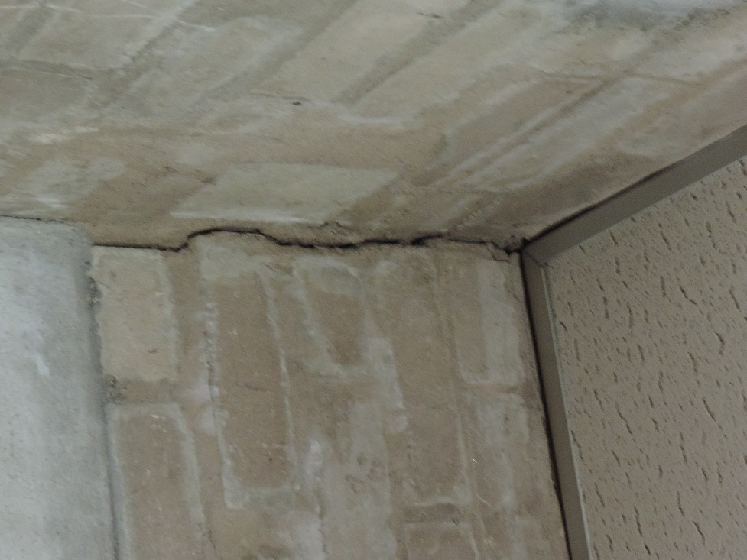
Photo 27 – Store 7 vertical cracking SW corne

